Policy Based Routing

Mason and Hoffman – Period 6-8

Jeffrey Zhang

Purpose

The purpose of this lab is to route or block different types of traffic by configurating the router. Within this lab, I set up two identical web servers (different IPs) which both have HTTP and HTTPS enabled. If we only utilize normal routing, both HTTP and HTTPS in both servers should be accessible. However, we can configure the router so that only HTTP in Server Alpha (HTTP server) is accessible while only HTTPS on Server Bravo (HTTPS server) is accessible separately.

Background

Policy-based routing (PBR) tells routers to forward data packets based on the policies defined by network administer. These policies can be protocol type (HTTP or HTTPS), packet sizes, source/destination addresses, etc. In application, it’s a way to have customized policies to override automatic routing protocol decisions. Essentially like a manual override to router decisions. PBR works by selectively routing/modifying data packets based on existing access lists and other criterion (in this lab, we applied the policies to a destination address, so we used an extended access list). Apache is the software we used to set up HTTP and HTTPS service. In this lab, both servers run Apache on Ubuntu OS. More than a third of the world’s active websites today at any given moment are run on Apache. Another portion of this lab is configuring an HTTPS server. HTTPS is secure because it uses SSL (Secure Socket Layer), which uses asymmetric encryption. Asymmetric encryption means with a public encryption key, you can only encrypt the data, but not decrypt it. It’s a one-way street. SSL algorithm is based on Elliptic Curve Cryptography, which if you input x, you can get an y-value, but it’s almost impossible to work back and get x if you are given y. The only way to decrypt the data (get the original x with y) is to a private key, which is only known locally in the server. A public encryption key needs a certificate to operate. In a large enterprise, a certificate can cost up to $1500 from a trusted authority, who constantly mitigating attacks. However, in this small network, we will have Apache to use a self-assigned SSL certificate to run HTTPS.

Lab Summary

First, I installed the Linux Ubuntu Operation System on both servers. Then, I installed Apache to run on both HTTP and HTTPS server. After checking the connectivity of both servers on both website protocols. I implemented Policy-Based Routing that allows only HTTP and blocks HTTPS on HTTP Server, and block HTTP and allows only HTTPS Server.

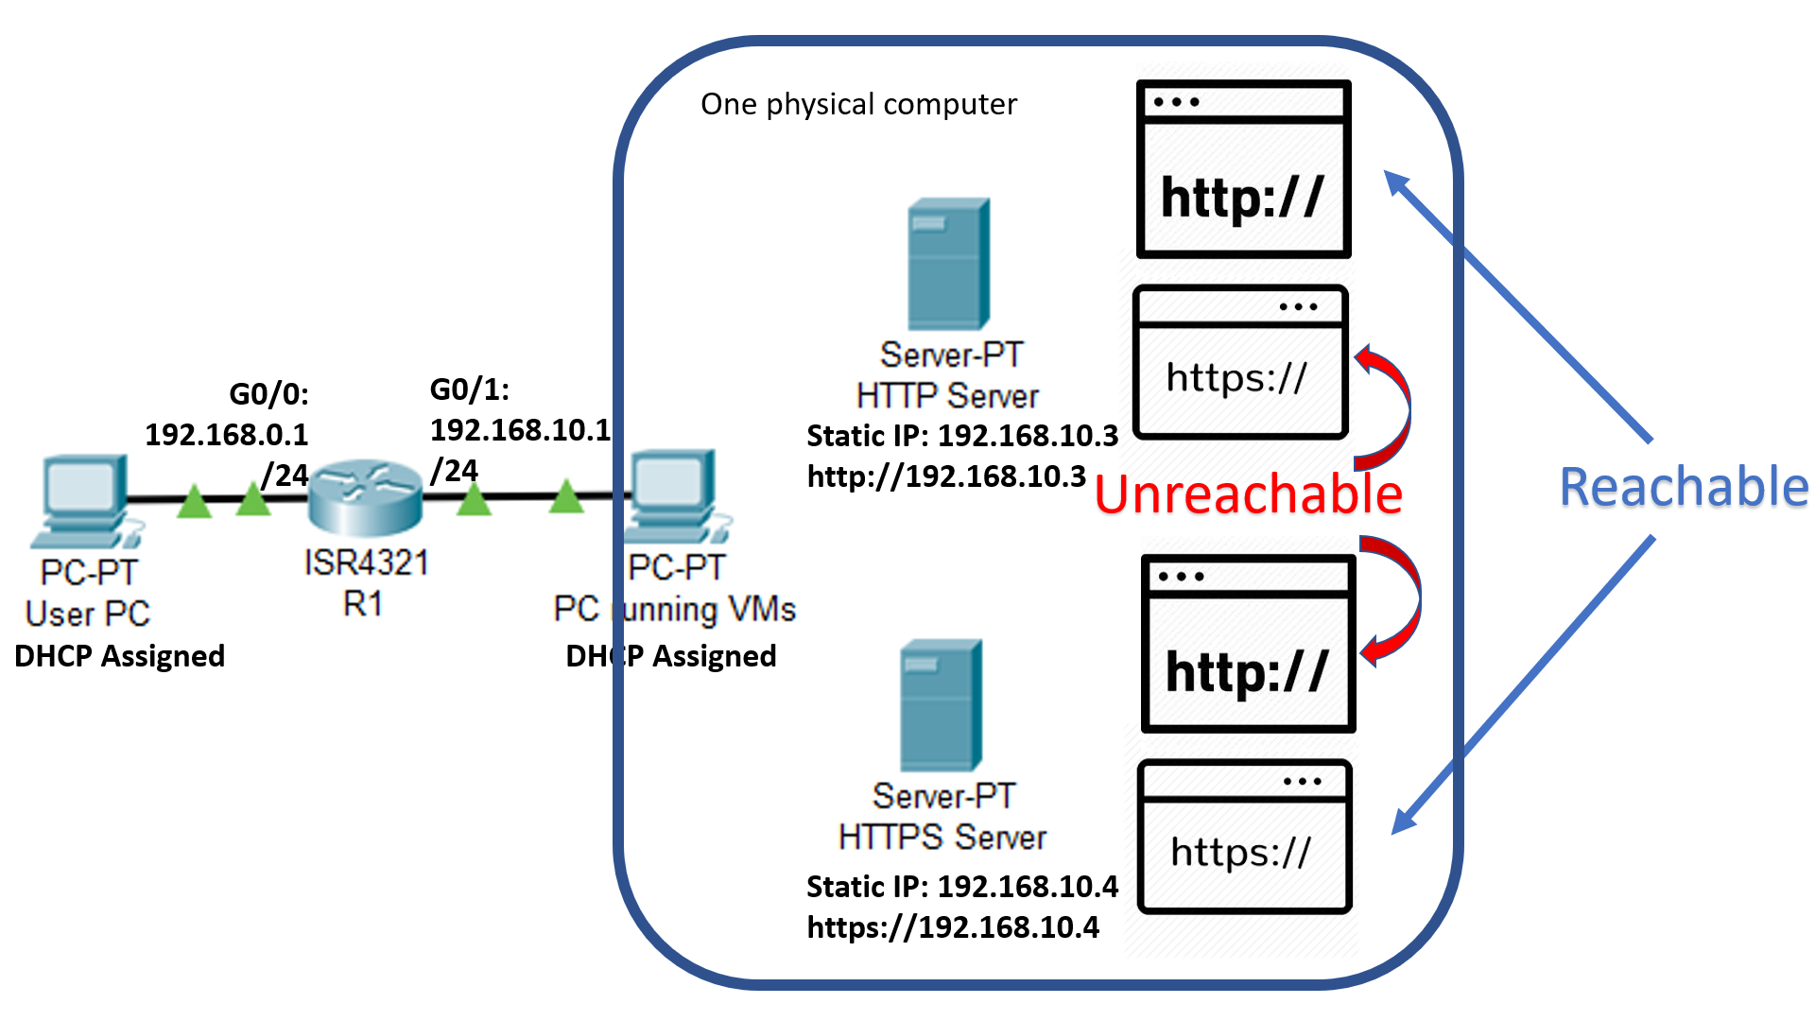

====================================

In VMware, load an ISO image of Ubuntu 18.04.2. Other versions of Linux (such as Kali Linux) works as well, Apache is a universal application. Run through the normal username and password registration. We have two servers, so we need to perform these steps twice.  
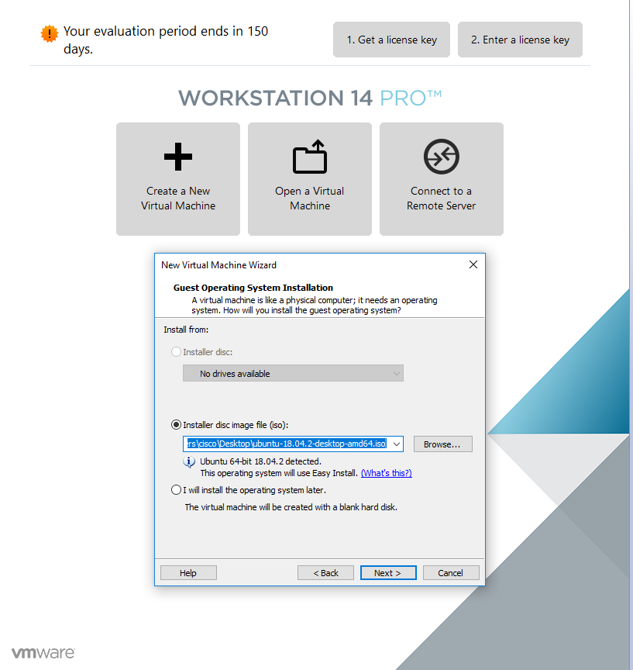

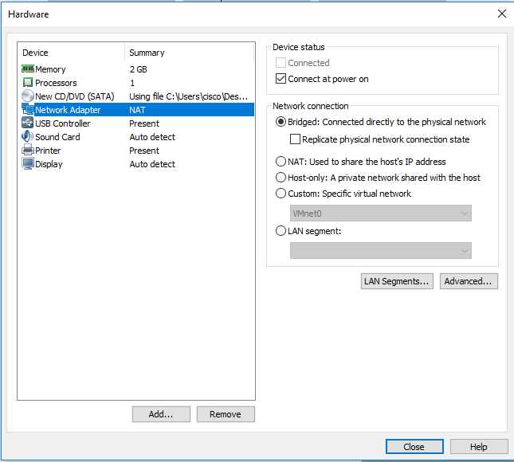   
Since website servers need to have distinct IP address separated from physical PC and the other VM servers, we must use NAT for Network Adapter. However, in my lab, my physical PC is connected to Internet with WIFI, using NAT means VM machine lost connections to outside Internet. This problem will be addressed later.

Then, I want to do a **“sudo apt-get update”,** which enables me to download applications like Apache. But the Error messages shows that the update failed.

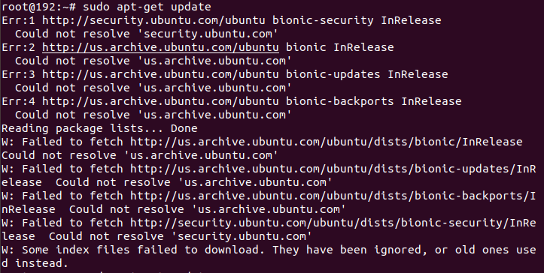

So, I checked my connectivity—which shows that I am currently not connected.

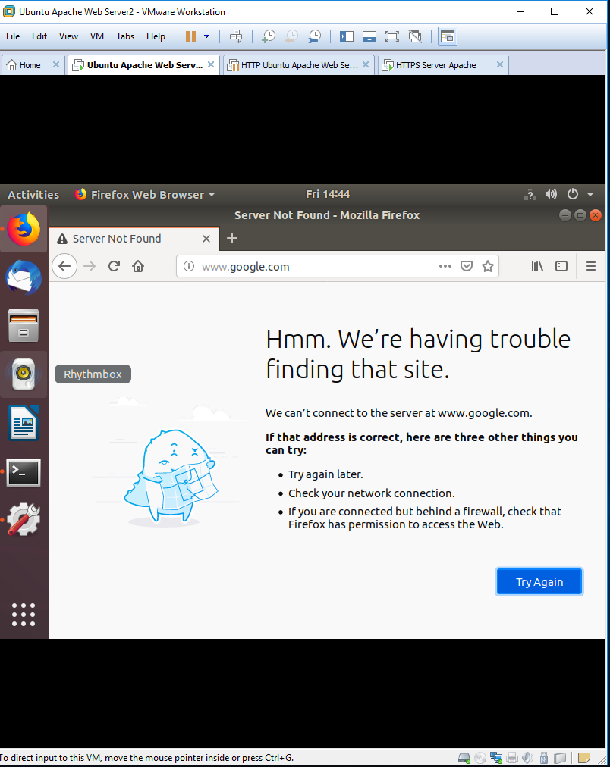

To establish connectivity, first, we utilized bridged connection to share an Internet connection with the physical PC hosts.

I’ll switch back to NAT connection after downloading all the necessary application packets.

In next image, I will try **sudo apt-get update** again, and this time, the update is successfully.



Then, issue: “**Apt install apache2”** to install application Apache2. Give permission to use disk space, and Apache will be installed.

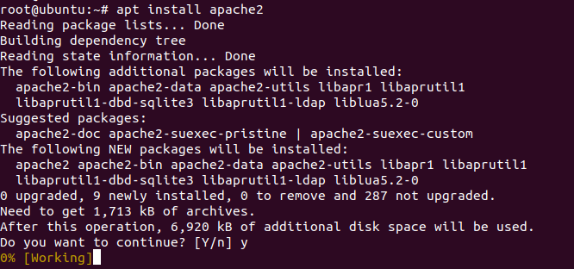

Then, initiate apache2 service. By default, the firewall is not enabled. But if you are not sure about it, you can use the following to confirm:

*“$ sudo ufw status ---check status*

*$ sudo ufw disable ---disable firewall”*

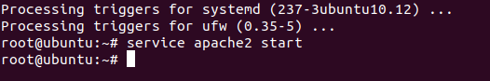

Apache2 is running from now on. We just need to switch back to NAT connection mode and configure a static IP address for our web server. DHCP assigned address also works, but I prefer static because static address is more reliable than DHCP.

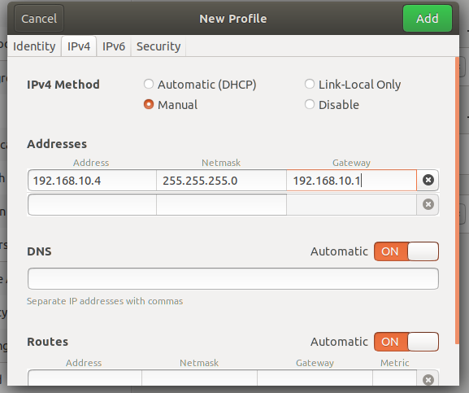

Since I’m using an Ubuntu GUI, I can just configure it through a graphic interface. Make sure to check it after configuring. If you are using a CLI interface, do “nano /etc/network/interfaces”.  Edit the network adaptor options and save the configuration page. If server IP addresses are DHCP assigned, make sure to do (ens33 is the default network interface, change it to the interface id of your own).

**“dhclient ens33 -v route add default gw 192.168.10.1 ens33”**

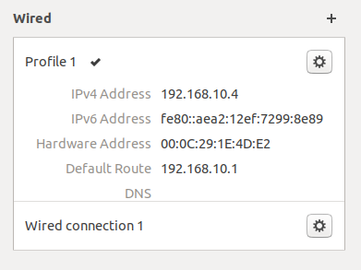

Double check that you have an address and server is connected through NAT. Go to a web browser on the physical PC that is running the VMware (Microsoft Edge won’t work). Type in server IP address. You can customize this page, but I’m not doing it in this lab.

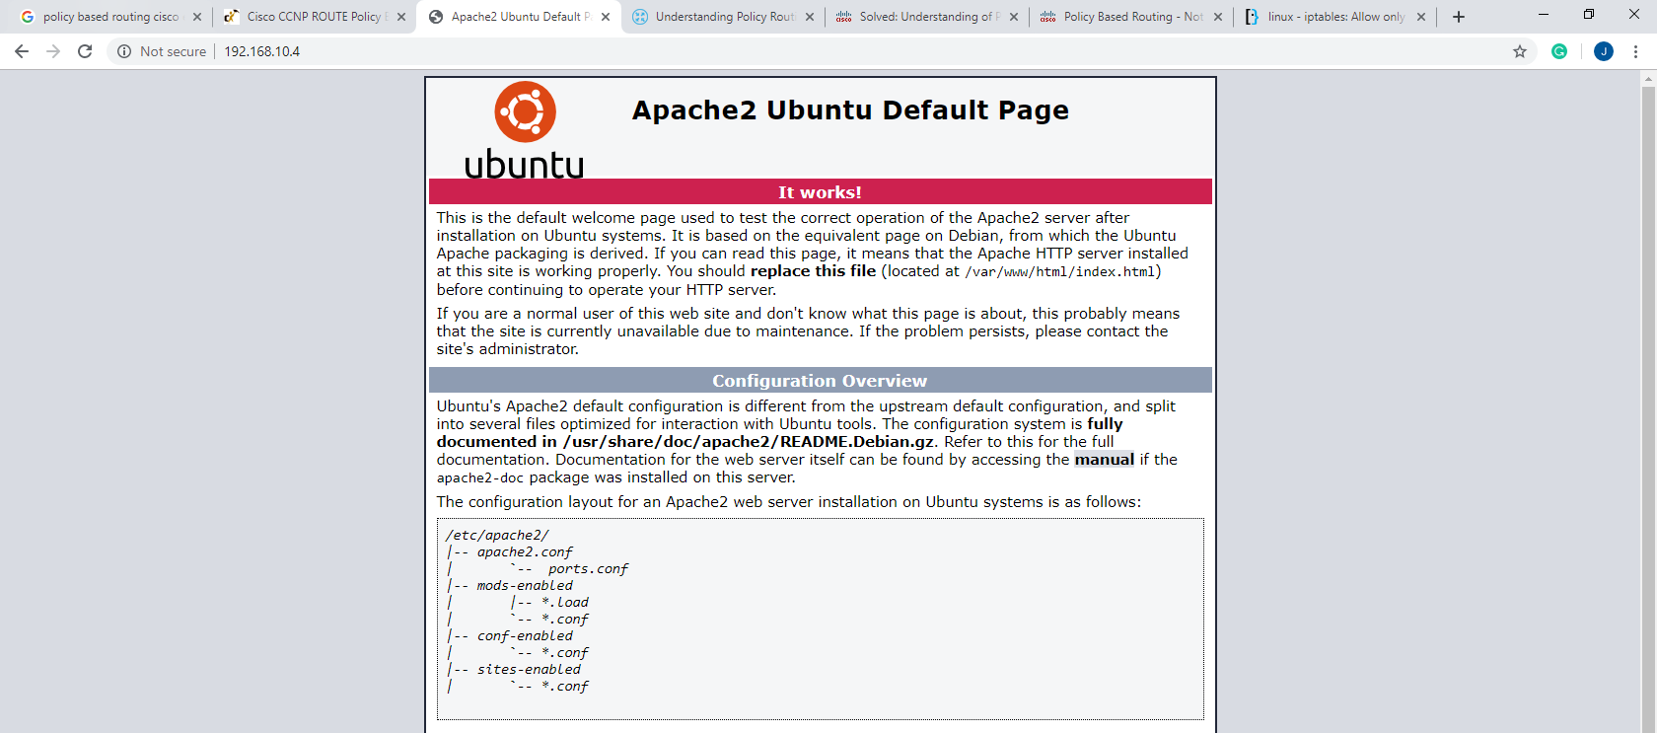

**HTTPS SSL Settings:**

Type in” “**a2enmond ssl”** to enable the Secure Socket Layer. And restart Apache.

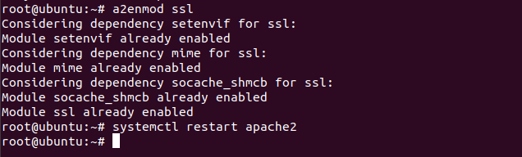

Then, we need to create a directory to store our self-assigned certificate. Type in:

**“mkdir /etc/apache2/ssl”**

to make a directory in the Apache2 folder.

Then, issue:

**“Openssl req-x509 -nodes -days 365 -newkey rsa:2048 -keyout /etc/apache2/ssl/apache.key -out/etc/apache2/ssl/apache.crt.”**

Private key for un-decryption is export to “apache.key”, and the certification for public key is apache.crt.

RSA 2048 defines the encryption algorithm to use. They will ask you several other personal questions for the certificate, the answer doesn’t really matter.

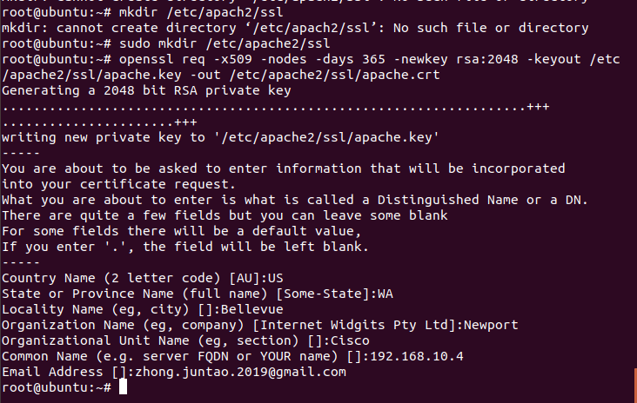

Then, enter “**nano /etc/apache2/sites-available/default-ssl.conf.”**

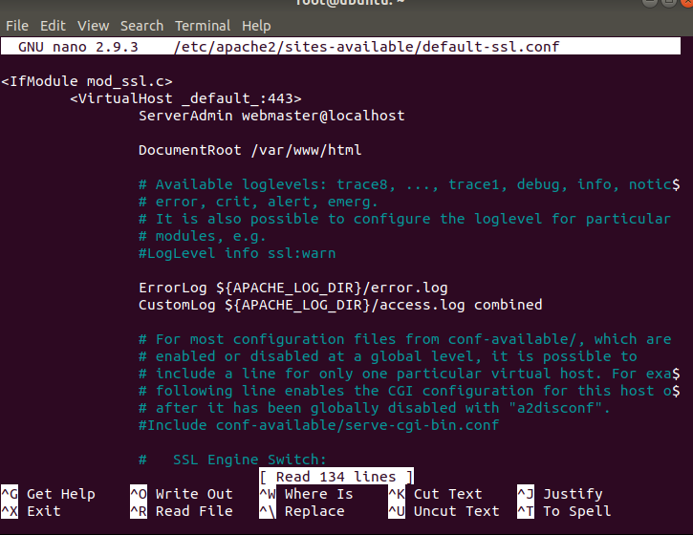

As you scroll down, you will find the code that directs to private key and ssl certification. You will need to change it to two files that we made just now.

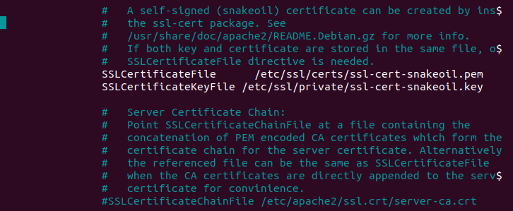

At this point, the HTTPS is still not running. You need to reload Apache for it to run.

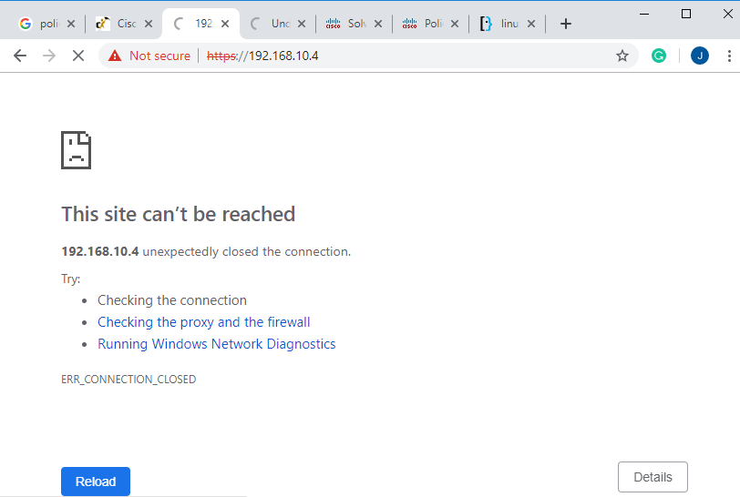

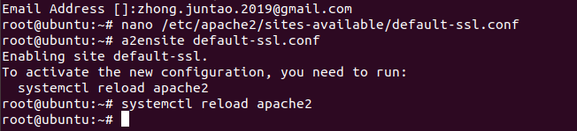

Success! The lock symbol on the top left means HTTPS has succeeded in establishing a secure connection; however, this HTTPS uses a self-assigned certificate, so it has a triangle next to it.

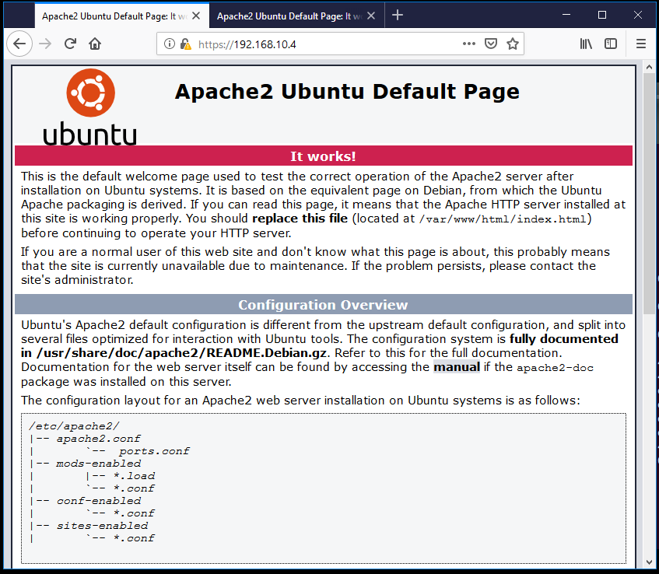

====================================

Configurations

Below is the **router** configuration for the router used within the topology.

ip policy route-map [name]-----------------define route-map (policy routing group)

access-list 100 permit tcp 192.168.0.0 0.0.0.255 host 192.168.10.3 eq www

-------------extended access list 100, anything HTTP (port 80, www traffic uses TCP) from 192.168.0.0/24 network belongs to access-list 100

route-map [name] permit 10------------------define policy NO.1 in this policy routing group

match ip address 10-----------if incoming traffic match the criteria in access-list 100

set ip next-hop 192.168.10.3---------then, route traffic to next-hop 192.168.10.3

set default interface Null0------------don’t route anything that is not in ACL 100

route-map [name] permit 20------------------define policy NO.2 in this policy routing group

Additional router commands:

(Note: With this configuration, router will route HTTP traffic to 192.168.0.3 and block the HTTPS traffic to it. And it will route HTTPS to 192.168.0.4, and block HTTP traffic to it, as expected in the lab diagram. After going trying both HTTPS and HTTP on both routers several times, router will gather some network data—which we can explore using show commands)

Router(config)# hostname Router

ip dhcp excluded-address 192.168.0.1 192.168.0.2

ip dhcp excluded-address 192.168.10.0 192.168.10.11

ip dhcp pool Users

network 192.168.0.0 255.255.255.0

default-router 192.168.0.1

ip dhcp pool Servers

network 192.168.10.0 255.255.255.0

default-router 192.168.10.1

lease infinite

interface GigabitEthernet0/0

ip address 192.168.0.1 255.255.255.0

ip policy route-map Routing

no shutdown

interface GigabitEthernet0/1

ip address 192.168.10.1 255.255.255.0

no shutdown

access-list 100 permit tcp 192.168.0.0 0.0.0.255 host 192.168.10.3 eq www

access-list 101 permit tcp 192.168.0.0 0.0.0.255 host 192.168.10.3 eq 443

access-list 102 permit tcp 192.168.0.0 0.0.0.255 host 192.168.10.4 eq www

access-list 103 permit tcp 192.168.0.0 0.0.0.255 host 192.168.10.4 eq 443

route-map Routing permit 10

match ip address 100

set ip next-hop 192.168.10.3

set default interface Null0

route-map Routing permit 20

match ip address 101

set interface Null0

route-map Routing permit 30

match ip address 102

set interface Null0

route-map Routing permit 40

match ip address 103

set ip next-hop 192.168.10.4

set default interface Null0

**Router#show route-map**

route-map Routing, permit, sequence 10

Match clauses:

ip address (access-lists): 100

Set clauses:

ip next-hop 192.168.10.3

Nexthop tracking current: 0.0.0.0

192.168.10.3, fib_nh:0,oce:0,status:0

default interface Null0

Default Interface tracking current: NULL

Null0, adj_lh:0,oce:0,status:0

Policy routing matches: 33 packets, 3080 bytes

route-map Routing, permit, sequence 20

Match clauses:

ip address (access-lists): 101

Set clauses:

interface Null0

Interface tracking current: NULL

Null0, adj_lh:0,oce:0,status:0

Policy routing matches: 18 packets, 1188 bytes

route-map Routing, permit, sequence 30

Match clauses:

ip address (access-lists): 102

Set clauses:

interface Null0

Interface tracking current: NULL

Null0, adj_lh:0,oce:0,status:0

Policy routing matches: 48 packets, 3168 bytes

route-map Routing, permit, sequence 40

Match clauses:

ip address (access-lists): 103

Set clauses:

ip next-hop 192.168.10.4

Nexthop tracking current: 0.0.0.0

192.168.10.4, fib_nh:0,oce:0,status:0

default interface Null0

Default Interface tracking current: NULL

Null0, adj_lh:0,oce:0,status:0

Policy routing matches: 106 packets, 15941 bytes

**Router#show ip access-lists**

Extended IP access list 100

10 permit tcp 192.168.0.0 0.0.0.255 host 192.168.10.3 eq www (32 matches)

Extended IP access list 101

10 permit tcp 192.168.0.0 0.0.0.255 host 192.168.10.3 eq 443 (36 matches)

Extended IP access list 102

10 permit tcp 192.168.0.0 0.0.0.255 host 192.168.10.4 eq www (96 matches)

Extended IP access list 103

10 permit tcp 192.168.0.0 0.0.0.255 host 192.168.10.4 eq 443 (106 matches)

(Note: There should be matches whether the route forwards or blocks the packets—router must categorize the packet (with access-list) before making decision to forward it.)  
This is the configuration for the Linux terminal used within the topology:

Abstract:

HTTP config:

apt-get update

apt install apache2

service apache2 start

---From this point, the HTTP server is already running. The IP address of HTTP website is server address (which can be static address or DHCP address).

HTTPS Config:

a2enmod ssl---------------------------------------------------Apache enable SSL (Secure Socket Layer)

service apache2 restart

mkdir /etc/apache2/ssl--------------------------------------------Make directory /etc/apache/ssl

openssl req -x509 -nodes -days 365 -newkey rsa:2048 -keyout /etc/apache2/ssl/apache.key -out /etc/apache2/ssl/apache.crt

------------------generate a ssl key using RSA encryption algorithm, and push it out to /etc/apache2/ssl/apache.key and /etc/apache2/ssl/apache.crt

nano /etc/apache2/sites-available/default-ssl.conf

find these two lines and edit them inside file:

SSLCertificateFile /etc/apache2/ssl/apache.crt

SSLCertificateKeyFile /etc/apache2/ssl/apache.key

Save and exit /etc/apache2/sites-available/default-ssl.conf

a2ensite default-ssl.conf

service apache2 restart

Problems

Microsoft Edge didn’t trust the locally developed Apache website:

This problem haunted me for a while, as I tried desperately to troubleshoot my Apache server. It turned out that my Apache servers work perfectly fine, but just Microsoft Edge don’t trust the less-secure local servers (it doesn’t trust self-assigned certificate by default, which makes sure that client is not talking to a fake server).

The solution is very easy: use Chrome or Firefox instead. Switch browsers with differing certificate scanning policies.

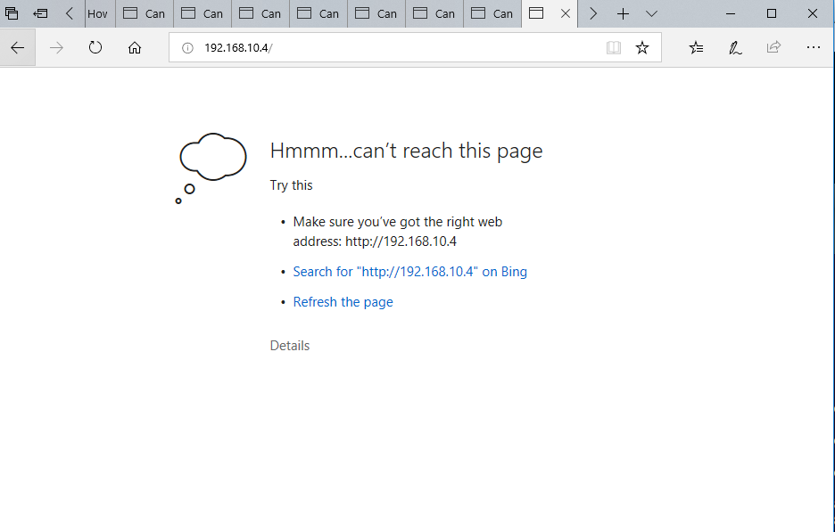

**Server Linux VM can’t connect to Internet and download Apache under NAT mode:**

Apache needs to be downloaded online, so server must connect to the Internet first. Thus, we can bridge the network to download necessary files, then use NAT connections.

**Router routes both all traffic between two networks without blocking it:**

Since both networks are directly connected to the router, “not routing protocol” is the necessary communication in two. If router routes everything across, then Policy-Based Routing is not working.

I suspected that I placed the extended ACL in the wrong interface; and I find the problem:

**Router(config-if)#do debug ip policy**

Policy routing debugging is on

Router(config-if)#

*Apr 26 15:04:56.527: IP: s=192.168.10.4 (GigabitEthernet0/1), d=192.168.0.3, le n 52, **FIB policy rejected(no match)** - normal forwarding

*Apr 26 15:04:56.527: IP: s=192.168.10.4 (GigabitEthernet0/1), d=192.168.0.3, le n 40, **FIB policy rejected(no match)** - normal forwarding

*Apr 26 15:04:56.535: IP: s=192.168.10.4 (GigabitEthernet0/1), d=192.168.0.3, le n 1464, **FIB policy rejected(no match)** - normal forwarding

… and a ton of **“FIB policy rejected(no match)…”**

Theoretically all webpage traffic within this network should have a match, but there is no match. It’s because that I put command “**ip policy route-map Routing”** on the wrong interface (G0/1). The right interface should be one facing users, not servers. It makes sense though: traffic must be decided where to go first, before it arrives at the destination interface.

So, I changed it, and the debug message shows.

Debug messages continues:

*Apr 26 15:27:58.815: IP: s=192.168.0.3 (GigabitEthernet0/0), d=192.168.10.4, len 52, **FIB policy match**

*Apr 26 15:27:58.815: IP: s=192.168.0.3 (GigabitEthernet0/0), d=192.168.10.4, len 52, PBR Counted

*Apr 26 15:27:58.815: IP: s=192.168.0.3 (GigabitEthernet0/0), d=192.168.10.4, len 52, policy match

*Apr 26 15:27:58.815: IP: route map Routing, item 30, permit

*Apr 26 15:27:58.815: IP: s=192.168.0.3 (GigabitEthernet0/0), d=192.168.10.4 (Null0), len 52, **policy routed**

*Apr 26 15:27:58.815: IP: GigabitEthernet0/0 to Null0 192.168.10.4

*Apr 26 15:27:58.819: IP: s=192.168.0.3 (GigabitEthernet0/0), d=192.168.10.4, len 52, FIB policy match

*Apr 26 15:27:58.819: IP: s=192.168.0.3 (GigabitEthernet0/0), d=192.168.10.4, len 52, PBR Counted

*Apr 26 15:27:58.815: IP: s=192.168.0.3 (GigabitEthernet0/0), d=192.168.10.4 (Null0), len 52, policy routed

*Apr 26 15:27:58.815: IP: **GigabitEthernet0/0 to Null0** 192.168.10.4

All the traffic contained matches, and the debug message recorded the decisions made by the router, such as “policy routed” (pass) or “to Null0” (blocked). At this point, the HTTP and HTTPS servers work as expected.

Conclusion

In this lab, I installed and configure two Apache servers based on Linux Ubuntu. Besides the basic HTTP, I allow servers to self-assign certificates to run HTTPS. Then, I configureed PBR, which blocks and sends traffic through the specified access list. I also expanded my networking knowledge by learning concepts such as asymmetric encryption, ssl, and self-assigned certificates.